Carlos Orduna
CST338

Recreating Lab 2 into an Android App:

Phase 1: Design Layout

1.-Three Vector Assets images that will change every time the player plays a bet
2.-One TextView field with the starting amount, this TextView will keep track of the winnings and update every time the player puts a bet.
3.-One EditText number value that will take a number between 0 and the current money to place a bet
4.- Include two buttons for the player, a Bet button that will take the value inside the EditText above and play the game, and an Instructions button that will take the player to a new Activity window with the winning multiplier.
You will have to have two different activities for this project, your Main Activity window, and an instructions window with a button to go back to the Main Activity.

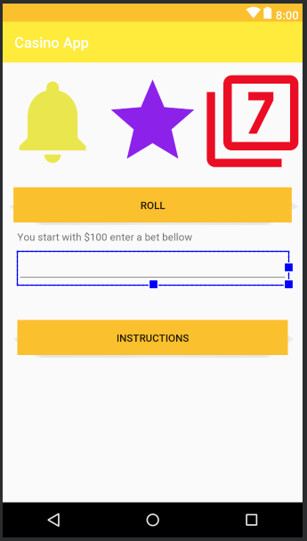

Phase 2: Create the game
Use what you learned on lab 2 to create a similar slot game. Every time the user places a Bet and presses the button, the images should change depending on the weighted percentages of each item. This should also take account of what the roll was and change the winnings whether they win or lose.
The images we will be using are Hearts – Bells -Stars – and the number seven.
The current weights for the images will be – ½ Stars ¼ Bells 1/8 Hearts & 1/8 Seven
The winnings shall be the same as Lab 2 –
Bells – x – x = 5x
Bells – Bells – x = 10x
Bell - Bell - Bell = 15x
Star - Star - Star = 20x
7 - 7 - 7 = 30x

Make sure the player puts in a viable bet.
Final product images:
UML:
